Q1 : Assignment 1: Automated Instance Management Using AWS Lambda and Boto3.

Step 1: Created two ec2 instances with tag - tag:Auto-Start and tag:Auto-Stop.

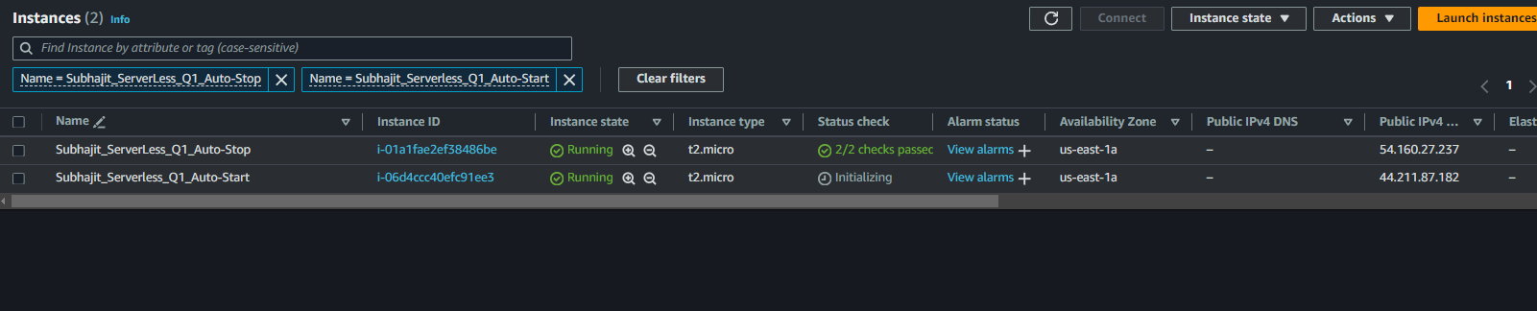

Step 2: Navigated to IAM, created a role, and attached AmazonEc2FullAccess.

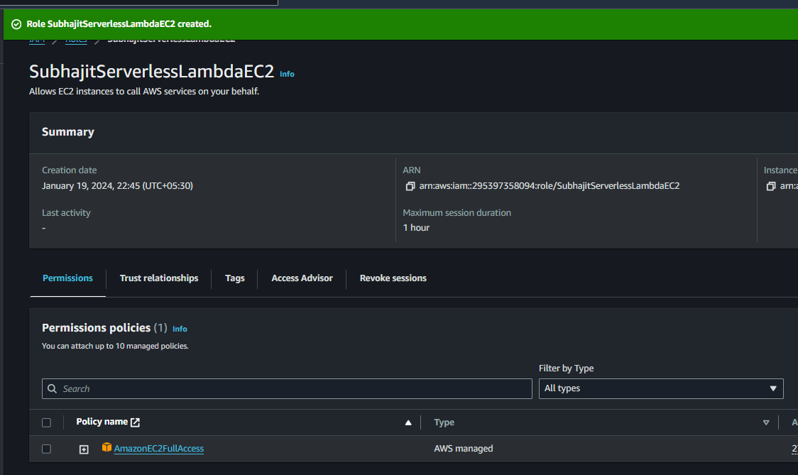

Step 3: Created a Lambda Function with Python 3.x and attached the role that was created.

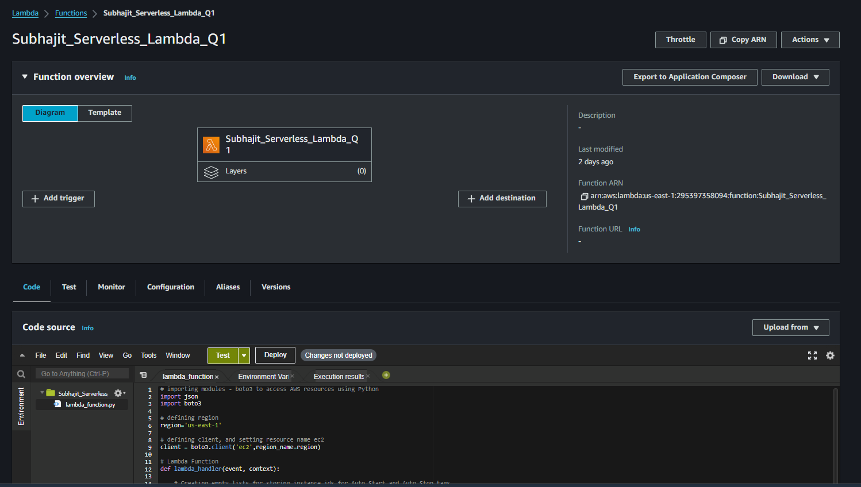

Step 4: Python code written using boto3 module and <https://boto3.amazonaws.com/v1/documentation>

# importing modules - boto3 to access AWS resources using Python

import json

import boto3

# defining region

region='us-east-1'

# defining client, and setting resource name ec2

client = boto3.client('ec2',region_name=region)

# Lambda Function

def lambda_handler(event, context):

# Creating empty lists for storing instance ids for Auto-Start and Auto-Stop tags

start_instance_ids = []

stop_instance_ids = []

# Using describe_instances from AWS botob3 documentaion, store it in a variable

response = client.describe_instances(

# defining filters so that the variable will only include the instances that have specific tags

Filters = [

{

'Name' : 'tag:Action',

"Values" : ['Auto-Start','Auto-Stop']

}

]

)

# extracting the instance ids from response recieved from aws

for reservation in response['Reservations']:

for instance in reservation['Instances']:

for tags in instance['Tags']:

if tags['Value'] == 'Auto-Start':

start_instance_ids.append(instance['InstanceId'])

elif tags['Value'] == 'Auto-Stop':

stop_instance_ids.append(instance['InstanceId'])

# printing the start and stop instances

print(start_instance_ids)

print(stop_instance_ids)

# Using start_instances we will start the instances with tag 'Auto-Start'

print("Starting Instances with tag:Auto-Start")

client.start_instances(InstanceIds=start_instance_ids)

print("start complete")

# Using stop_instances we will stop the instances with tag 'Auto-Stop'

print("Stopping Instances with tag:Auto-Stop")

client.stop_instances(InstanceIds=stop_instance_ids)

print("Stop complete")

# returning a value once the function is done

return {

'result': "Task Completed"

}

Step 5: Manually tested the function and the function is stopping the ec2 instance with tag Auto-Stop and starting the instances with tag Auto-Start.

IAM Role created in order to execute Lambda functions.

